Journey Through The Bible

**Miriam**

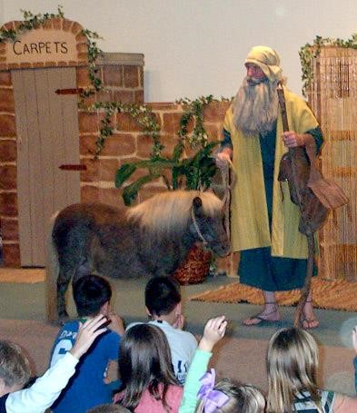

Exodus 2:1-10

My name is Miriam, and I would like to tell you about an adventure that I had with my baby brother. My mother and father are Hebrews from the house of Levi, and we all live in the land of Egypt. We are slaves of Pharaoh, ruler of Egypt, and we have to work very, very hard making bricks .

When Pharaoh noticed that the Hebrews were beginning to outnumber the Egyptians, he became afraid that we would come together, fight against them, and leave Egypt. Pharaoh ordered the women who helped the Hebrew women in the birth of their babies to kill all of the baby boys. These women are called midwives, and they were afraid that God would be angry if they did this terrible thing. God blessed the midwives for not killing the Hebrew baby boys.

Pharaoh then ordered all of his people to throw every baby boy Hebrew into the Nile River to drown but to save the Hebrew baby girls.

My mother had a beautiful baby boy during this scary time. She hid him for three months, but when he began to grow, she could not hide him any longer. I think that my mother was a very wise lady. Guess what she did? She made a basket and covered it with black, sticky tar so that the water would stay out. Then my mother put my baby brother into the basket and set it among the reeds (tall weeds) in the Nile River.

I stood on the river bank to find out what would happen to my baby brother. I was so scared. Then I saw the daughter of Pharaoh come down to bathe in the Nile River. Her women servants were with her. All of a sudden, the daughter of Pharaoh saw the basket and sent a maid to bring the basket to her. When the daughter of Pharaoh opened the basket and saw my crying baby brother, she felt sorry for him and said, "This **is** one of the Hebrew's children."

I said to Pharaoh's daughter, "Shall I go and call a nurse for you from **the** Hebrew women that she may nurse the child for you?"

Pharaoh's daughter said, "Go ahead."

I ran and got my mother. Pharaoh's daughter said to my mother," Take this child away and nurse him for me, and I shall give you your money."My mother took her baby and nursed him until he grew larger. My mother then took my baby brother to Pharaoh's daughter and he became her son. She named him Moses because she took him out of the water.

This is how God let my mother and me save my baby brother's life.But Moses' adventures were only beginning.

**Memory Verse:**

☼ **Ask, and it will be given to you; seek, and you will find.**

**What did you learn from this lesson?**

☺ **Miriam helped save her brother by obeying her mother.**

**Do you know? Answer on back page**

**?** **Who rescued Moses from the Nile River?**

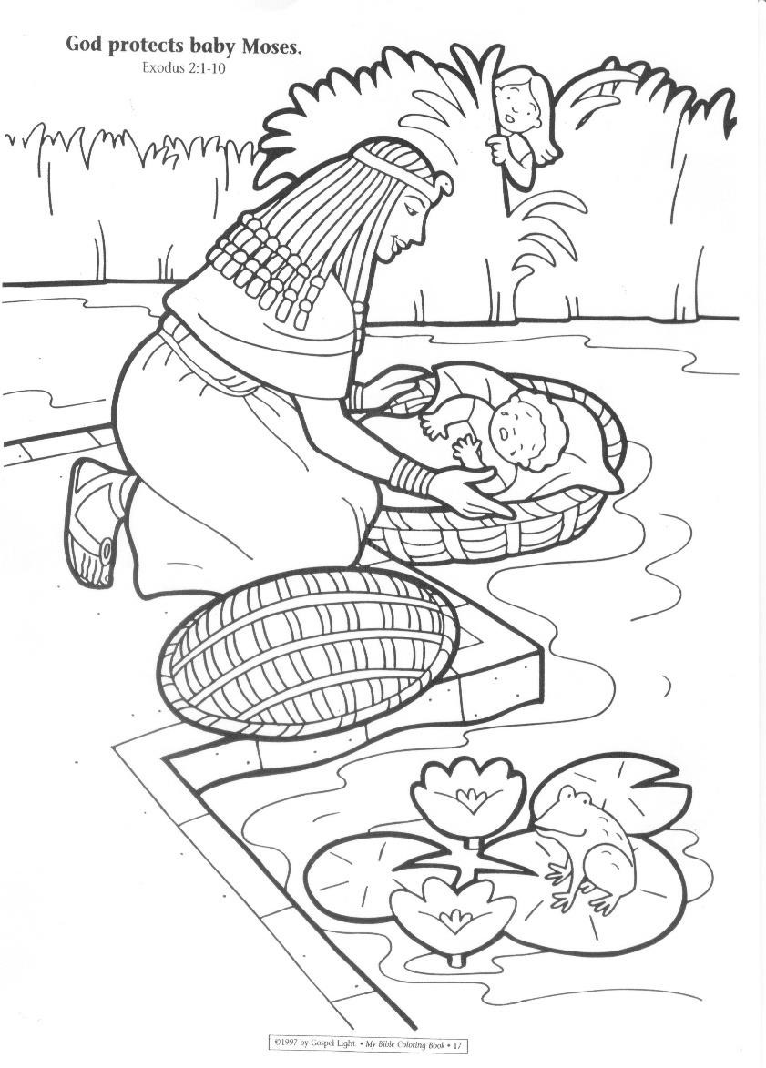

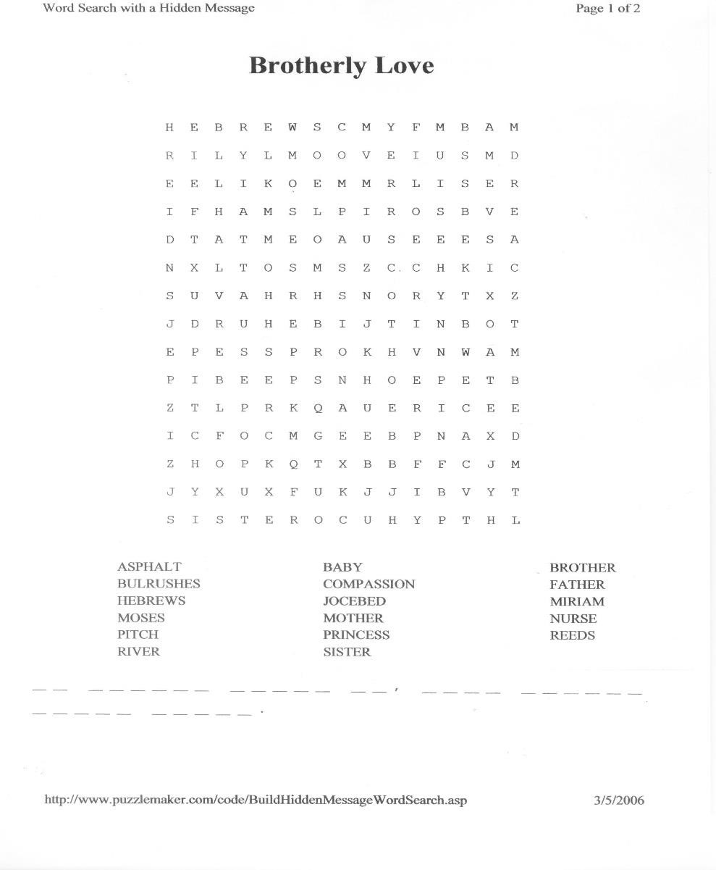

**? Answer to do you know.**

**● Pharaoh’s daughter.**